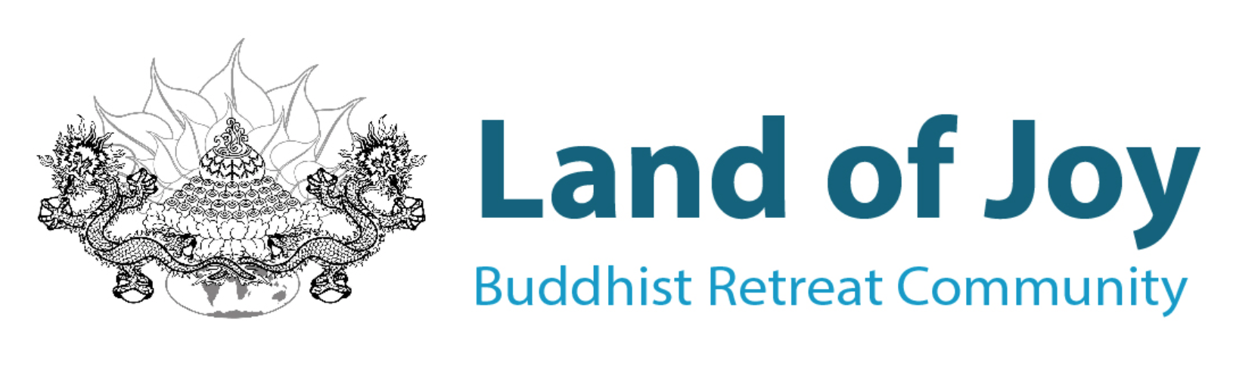
Centre Director
Overview & Description (March 2022)

The Centre’s needs are two in nature – spiritual or educational and material. People and finances are needed to develop facilities. The Centre Director has to know both. Lama Yeshe, 1983
The Board of Trustees is seeking a new Centre Director to continue developing Land of Joy as a warm and welcoming FPMT UK retreat centre, where people from all walks of life can develop their natural potential to live responsibly with compassion and wisdom.
We are looking for a flexible and resourceful Director to lead a harmonious team, confident of working effectively with the Land of Joy stakeholders, including the Board, our donors and supporters, other FPMT UK people and organisations. A person with a good heart, an excellent communicator in the English language with proven collaborative leadership skills. The successful candidate will have a strong commitment to, or at least sincere respect for, Lama Zopa Rinpoche, familiarity with Buddhism, the FPMT International organisation and an awareness of the spiritual purpose of Land of Joy.
Land of Joy operates solely on a Generosity Model - we do not charge for retreats, teachings, accommodation, or food – and we are pleased to be gradually realising our goal of funding the programme of events, volunteer care and running costs all through the generosity of others. Targeted fundraising for larger projects, such as the Coach House conversion and the ongoing maintenance of a large country house is a necessity, requiring skilful fiscal management. The new Director should have prior experience of offering service, ideally within the FPMT organisation, or have worked within a non-profit business. Whatever level of experience or knowledge you may have, if you are drawn to offering service in this way, please get in touch and let’s talk about it.
Everyone living and working at Land of Joy is a volunteer and no one in any position receives financial remuneration for their work. The main reward for offering service at Land of Joy is the pleasure of supporting oneself and others on the path to enlightenment. Volunteers benefit from working and living together in friendship, to develop and achieve shared goals, with an emphasis on maintaining harmony and generating positive spiritual energy. Additional benefits include home cooked meals, a room of your own, rostered days off and opportunities to engage in spiritual practice and retreat at Land of Joy and elsewhere. The Generosity Model underpins our core values of Buddhism: to give freely without expectation of any return. The resulting atmosphere of care, patience and respect are frequently experienced and commented on by new and returning retreatants.

Working closely with the Board of Trustees, the Spiritual Programme Coordinator (SPC) and other key team members, the Centre Director will bring determination and steady leadership into practice, guiding Land of Joy through its next stage of development. The key duties for the Centre Director include the following:

- Together with the Board of Trustees, developing sustainable strategies with a clear vision, translating ideas into concrete goals, policies, and outcomes.
- Implementing the FPMT mission statement and vision of the Board of Trustees in consultation with team members and the wider community to maintain the successful operation of the Centre.
- Overseeing all areas of Land of Joy’s activities including the development of a well-balanced retreat programme, building and accommodation development, estate, and woodland management, monitoring the Risk Register for good practice, etc.
- Maintaining financial stability through sound fiscal management, monitoring monthly and annual operating budgets; developing fundraising campaigns, grant applications, expanding the Branches of Joy membership programme and investigating income generation opportunities.
- Offering compassionate organisational and management skills, enabling team members to grow professionally and work cohesively to achieve shared goals.
- Strengthening links with FPMT UK groups and sister organisations, attending regional and international FPMT meetings and training events.
- Creating outreach programmes to engage with local communities, other faith-based organisations, as well as implementing diversity and inclusivity policies and programmes.
- Ensuring that Land of Joy and all who live, work, and teach at the Centre abide by UK law and FPMT policy and guidelines, complying with relevant legislation such as health and safety, safeguarding, and ethical policies.
- Ensuring legal compliance, in consultation with the Board, and timely delivery of all reports to statutory authorities such as the Charities Commission, HMRC and Companies House.
- Communicating Land of Joy’s vision well to a variety of audiences with excellent verbal, written and editing skills.
- Any other responsibilities commensurate with the position.

The successful candidate will:
- Have an abundance of patience, kindness, and compassion; the ability to listen deeply and act appropriately, and a good sense of humour.
- Be an excellent communicator with a strong, tactful, and measured approach, capable of building consensus and commitment to a direction agreed through consultative decision-making processes.
- Be computer and social media literate, with some marketing experience, as well as competence in maintaining relevant documentation, database, and other legal records.
The Centre Director will be living at Land of Joy, and we invite applicants interested in offering service to visit us at Greenhaugh Hall. It is important that both the existing onsite team and anyone considering this position are comfortable with one another before a commitment is made.

How to apply:
The closing date for applications is 30th May 2022. All applications must include:
- An application letter describing why you are interested in this position and how you might contribute to the successful running of the Centre, as well as addressing each aspect of the position description given above.
- A Curriculum Vitae.
- The names and email addresses of three referees: two professional and one Dharma related.
The position is subject to the Land of Joy Volunteer agreement. There will be a three-month probationary period for both sides and an initial agreement for 2 years, renewable up to two terms. All applicants must have the legal right to volunteer in the UK. Background checks will be carried out before the appointment is confirmed.
Interested, but feel you don’t have the means, experience, or skills to perform this role? We are more than happy to discuss any of these points with you before you make an application – we may even be able to tailor the role to suit your personal circumstances. Please email any questions or your completed application to: Charlotte Elliott, Chair@landofjoy.co.uk. We look forward to hearing from you.

Land of Joy was set up in 2008 as an FPMT project to meet the need for a retreat centre on the British mainland. Greenhaugh Hall, was purchased and opened its doors in 2015. Within a short space of six years, Land of Joy has developed into a thriving FPMT affiliated retreat centre, offering year-round personal retreat facilities, together with a variety of group retreats to meet all levels of spiritual interest and Dharma experience. Land of Joy is committed to providing the best possible retreat environment to help fulfill the FPMT mission.

Land of Joy is located within the inspiring natural peace and beauty of Northumberland National Park, a designated Dark Skies area. It consists of a large, well maintained country house, a newly renovated coach house, new individual retreat huts, numerous outbuildings and an extensive walled vegetable garden set within 42 acres of lush meadow and managed woodland. The village of Bellingham and the town of Hexham are accessible by a country bus service. The city of Newcastle, with access to international flight connections, is an hour’s drive away and can be reached by train or bus from Hexham.
We look forward to welcoming you to the community at Land of Joy!
Land of Joy
Greenhaugh Hall, Greenhaugh
HEXHAM, Northumberland, NE48 1PP
United Kingdom.
+44 (0)1434 240 412

